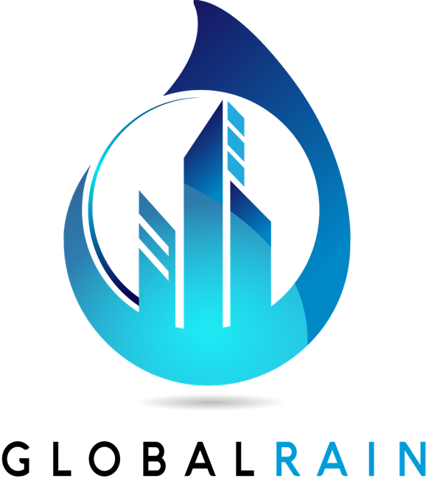

Practices for Secure Software Report

Table of Contents
Document Revision History 3
Client 3
Instructions 3
Developer 4
1. Algorithm Cipher 4
2. Certificate Generation 4
3. Deploy Cipher 4
4. Secure Communications 4
5. Secondary Testing 4
6. Functional Testing 4
7. Summary 4
8. Industry Standard Best Practices 4

Document Revision History

Version | Date | Author | Comments
1.0 | February 20, 2026 | Matthew Wood

Client



Developer
Matthew Wood

Algorithm Cipher

For the file verification requirements of Artemis Financial, I recommend the SHA-256 (Secure Hash Algorithm 256-bit) algorithm cipher.

- Overview: SHA-256 is a cryptographic hash function that generates a unique, fixed-size 256-bit (32-byte) signature for any given data input.

- Hash Functions & Bit Levels: As part of the SHA-2 family, it provides a significantly higher level of security and collision resistance than its predecessors, MD5 and SHA-1.

- Keys and Randomness: While hashing is a one-way process, the secure communication layer (HTTPS) utilizes Asymmetric encryption (RSA) for the initial handshake and Symmetric encryption (AES-256) for data transfer.

- History & Current State: SHA-256 is the current industry standard for data integrity and is required for compliance in financial and government sectors to prevent data tampering.

Certificate Generation

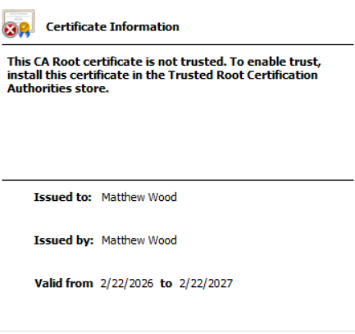

Deploy Cipher

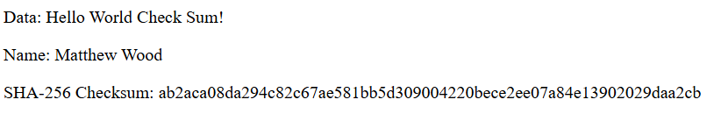

Secure Communications



Secondary Testing

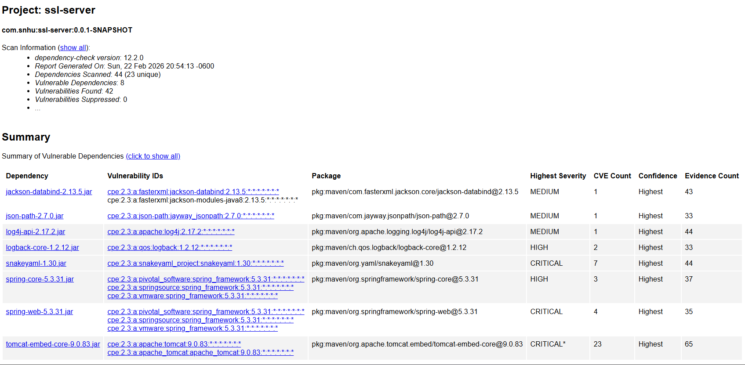

Functional Testing

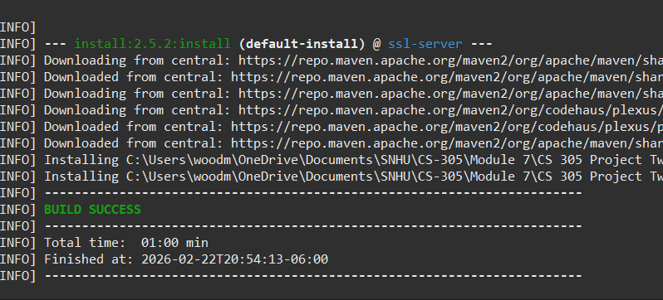

Summary

The refactoring of the Artemis Financial software application focused on adding critical layers of security to move from a vulnerable state to a production-quality integrated application. By following the Vulnerability Assessment Process Flow, I addressed several key security areas:

- Cryptography and APIs: I implemented the SHA-256 cryptographic hash algorithm to create a secure data verification step, fulfilling the client's need for checksum functionality.

- Client/Server: I refactored the communication layer from HTTP to HTTPS by generating a self-signed certificate and configuring secure server properties, ensuring encrypted data transfer.

- Code Review and Quality: I used manual review and static testing to identify syntactical, logical, and security vulnerabilities, ensuring the code complies with security testing protocols.

- Process: My process involved an iterative design where I refactored the code base, conducted Secondary Testing with the OWASP dependency-check tool, and performed Functional Testing to confirm the application executed without errors.

Industry Standard Best Practices

I applied industry-standard best practices for secure coding to mitigate known vulnerabilities and ensure the long-term well-being of the organization:

- Mitigation of Vulnerabilities: By implementing SHA-256 and TLS encryption, I ensured the application uses current encryption technologies to protect sensitive client data and financial information from unauthorized tampering or interception.

- Security Maintenance: I utilized the dependency-check tool to conduct a static security enhancement audit, identifying vulnerabilities in third-party libraries (such as Jackson-databind and SnakeYAML) that could compromise the system.

- Organizational Value: Applying these standards is essential for maintaining client trust and protecting Artemis Financial's reputation. It ensures compliance with financial data regulations and reduces the risk of data breaches, which is fundamental to Global Rain's mission that "Security is everyone's responsibility".

